Leadership

Overview
Importance of Leadership
Leadership Defined
• - Ways of conceptualizing leadership
• - Definition and components
Leadership Described
• - Trait vs. process
• - Assigned vs. emergent
• - Leadership and power
• - Leadership and coercion
• - Leadership and management
Peter G. Northouse, Leadership: Theory and Practice, Seventh Edition. © 2016 SAGE Publications, Inc.
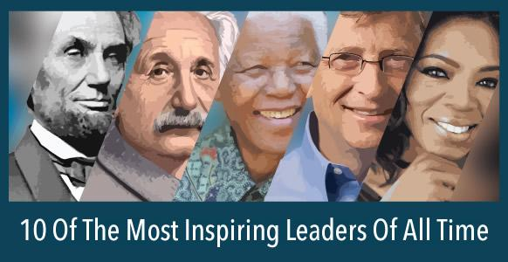Leaders

The Evolution of Leadership Definitions
• 1900-1929 – Control and centralization of power
• 1930s – Trait (attribute/ feature) approach
• 1940s – Group approach
• 1950s – Group theory, shared goals, and effectiveness • 1960s – Leadership as behavior
• 1970s – Organizational behavior
Peter G. Northouse, Leadership: Theory and Practice, Seventh Edition. © 2016 SAGE Publications, Inc.

Conceptualizing Leadership
Some definitions view leadership as:
• The focus of group processes
• A personality perspective
• An act or behavior
• The power relationship between leaders & followers • A transformational process
• A skills perspective
Peter G. Northouse, Leadership: Theory and Practice, Seventh Edition. © 2016 SAGE Publications, Inc.

Leadership Defined
Leadership
a process whereby an individual influences a group of individuals to achieve a common goal.
Peter G. Northouse, Leadership: Theory and Practice, Seventh Edition. © 2016 SAGE Publications, Inc.
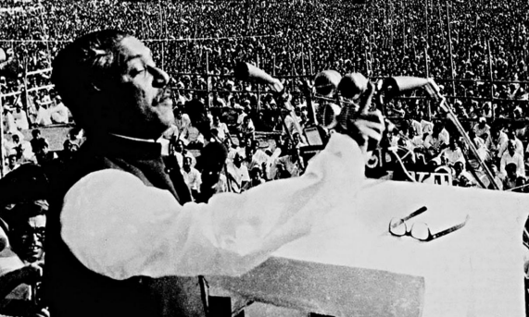Example

Trait vs. Process Leadership
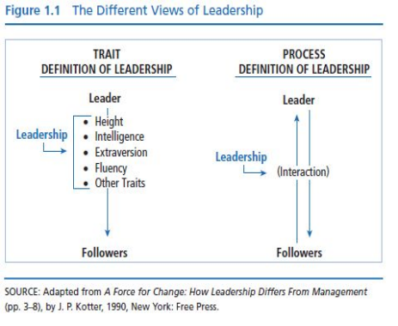
• Certain individuals
have special inborn
characteristics or
qualities that
differentiate them
from nonleaders.
Peter G. Northouse, Leadership: Theory and Practice, Seventh Edition. © 2016 SAGE Publications, Inc.

Trait Approach
Early 20th century - leadership traits were studied
The theories that were developed were called “great man” theories
They focused on identifying the innate qualities and characteristics possessed by great social, political, and military leaders (e.g., Catherine the Great, Mohandas Gandhi, Indira Gandhi, Abraham Lincoln and Napoleon).
It was believed that people were born with these traits, and that only the “great” people possessed them.
“He is born to be a leader”
Peter G. Northouse, Leadership: Theory and Practice, Seventh Edition. © 2016 SAGE Publications, Inc.
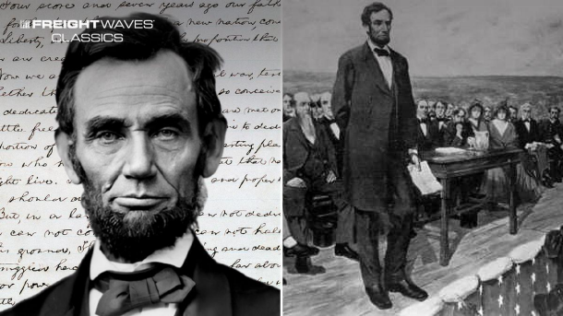Example

Process Approach
Leadership is a phenomenon that resides in the context of the interactions between leaders and followers.
It makes leadership available to everyone.
As a process, leadership can be observed in leader behaviors (Jago, 1982), and can be learned.
Peter G. Northouse, Leadership: Theory and Practice, Seventh Edition. © 2016 SAGE Publications, Inc.
Example
Assigned vs. Emergent Leadership Assigned Emergent
• Leadership based on occupying a position within an organization • Team leaders
• Plant managers
• Department heads • Directors
An individual perceived by others as the most influential member of a group or organization regardless of the individual’s title
• Emerges over time through
communication behaviors
• Verbal involvement
• Being informed
• Seeking others’ opinions
• Affected by personality and gender
Example - Assigned Leader
Example – Emergent leader
Leadership & Power
Power Bases of Social Power
• The capacity or potential to influence.
• Ability to affect others’ beliefs, attitudes, & actions
• Expert
• Legitimate
(sincere)
• Reward
• Coercive
(powerful)
• Information
French & Raven (1959), Raven (1965)
Peter G. Northouse, Leadership: Theory and Practice, Seventh Edition. © 2016 SAGE Publications, Inc.
Group Task – 10-15 Minutes
• See Table 1-1
• Choose one
• Discuss in your group • Find relevant examples
• Assign a team leader
• The team leader will have to summarize the group discussion
• 2-3 Minutes (each group leader)
Leadership & Coercion
Coercion Involves Examples of Coercive Leaders
• Use of force to effect change
• Influencing others to do something by manipulating rewards and penalties in the work environment
• Use of threats & punishments
• Adolf Hitler • Jim Jones
• Taliban leaders
Peter G. Northouse, Leadership: Theory and Practice, Seventh Edition. © 2016 SAGE Publications, Inc.
Shift in Leadership Power, Kellerman (2012)
• Power no longer the domain of leaders
• Followers demand more from leaders
• Access to technology has empowered followers
• Leaders are more transparent
• Leadership as social contract between leaders and followers Peter G. Northouse, Leadership: Theory and Practice, Seventh Edition. © 2016 SAGE Publications, Inc.

